Annual Review of Competence Progression
Checklist
ACCS AM CT3 2021

Evidence that trainee actively involved in the care of at patients presenting with acute medical problems (via WBAs or logbook) | YES / NO  (please circle)
Evidence that trainee have been actively involved in the management of medical inpatients | YES / NO
Evidence of engagement in outpatient training (via OPCAT/Clinics/SLEs) | YES / NO
Educational Supervisor Report (ESR) | YES / NO
Multi Source Feedback x 1  (Minimum of 12 responses with 3 consultants) | YES / NO
Multi Consultant Reviews sufficient for ESR (recommended 4)  (Recommended 2 must cover outpatient setting, 1 must cover managing acute patients) | YES / NO
Evidence of Quality Improvement Project via Quality Improvement Project Assessment Tool (QIPAT)  (Not mandatory) | YES / NO
Evidence of engagement with MRCP | Exams achieved
Deemed possible to achieve all three parts of MRCP by the end of IMT3/ST3 | YES/NO
Valid ALS certificate (if expired ES rating for CiP7 to be used) | Date
Evidence of engagement and teaching attendance when possible, including online learning | YES / NO

Consultant SLEs (Mini-CEXs or CBDs)  (minimum 4 SLEs total including 2 ACATs) | Date of assessment | Assessor’s name
- Mini CEX/CBD (please delete as appropriate)
- Mini CEX/CBD (please delete as appropriate)
- Mini CEX/CBD (please delete as appropriate)
- Mini CEX/CBD (please delete as appropriate)
ACATs (On acute take or on the ward round)  (minimum 4 SLEs total including 2 ACATs) | Date of assessment | Assessor’s name
- ACAT
- ACAT
- ACAT
- ACAT
Evidence of achievement of Practical Procedures to required level | Level  Required for ACCS CT3 | Level required for IMT completion | Achieved
- Advanced cardiopulmonary resuscitation (CPR) Direct current (DC) cardioversion | No minimum requirement set | Leadership of CPR team | Participation/  Leadership
- Central venous cannulation (internal jugular or subclavian | No minimum requirement set | Skills lab or satisfactory supervised practice | YES/NO
- Direct current (DC) cardioversion | No minimum requirement set | Competent to perform unsupervised | YES/NO
- Temporary cardiac pacing using an external device | No minimum requirement set | Skills lab or satisfactory supervised practice | YES/NO
- Access to circulation for resuscitation (femoral vein or intraosseous) | No minimum requirement set | Skills lab or satisfactory supervised practice | YES/NO
- Pleural aspiration for fluid (diagnostic) | No minimum requirement set | Competent to perform unsupervised | YES/NO
- Pleural aspiration (pneumothorax) | No minimum requirement set | Competent to perform unsupervised | YES/NO
- Intercostal drain for pneumothorax | No minimum requirement set | Skills lab or satisfactory supervised practice | YES/NO
- Intercostal drain for effusion¹ | No minimum requirement set | Skills lab or satisfactory supervised practice | YES/NO
- Nasogastric (NG) tube | No minimum requirement set | Competent to perform unsupervised | YES/NO
- Ascitic tap | No minimum requirement set | Competent to perform unsupervised | YES/NO
- Abdominal paracentesis | No minimum requirement set | Skills lab or satisfactory supervised practice | YES/NO
- Lumbar puncture | No minimum requirement set | Competent to perform unsupervised | YES/NO

Evidence of achievement of Clinical Capabilities in Practice (CiPs) to required level | Level  Required for ACCS CT3 | Level required for IMT completion | Level achieved
- Managing an acute unselected take | 2 | 3
- Managing an acute specialty-related take | 2 | 2
- Providing continuity to care to medical in-patients | 3 | 3
- Managing outpatients with long term conditions | 2 | 3
- Managing medical problems in patients in other specialties and special cases | 2 | 3
- Managing an MDT including discharge planning | 2 | 3
- Delivering effective resuscitation and managing the deteriorating patient | 3 | 4
- Managing end of life and applying palliative care skills | 2 | 3
Evidence of achievement of General Capabilities in Practice (CiPs) to required level | Meets or above expectations?
- Able to function successfully within NHS organisational and management systems | Meets/Above  (please circle)
- Able to deal with ethical and legal issues related to clinical practice | Meets/Above
- Communicates effectively and is able to share decision making, while maintaining appropriate situational awareness, professional behaviour and professional judgement | Meets/Above
- Is focussed on patient safety and delivers effective quality improvement in patient care | Meets/Above
- Carrying out research and managing data appropriately | Meets/Above
- Acting as a clinical teacher and clinical supervisor | Meets/Above

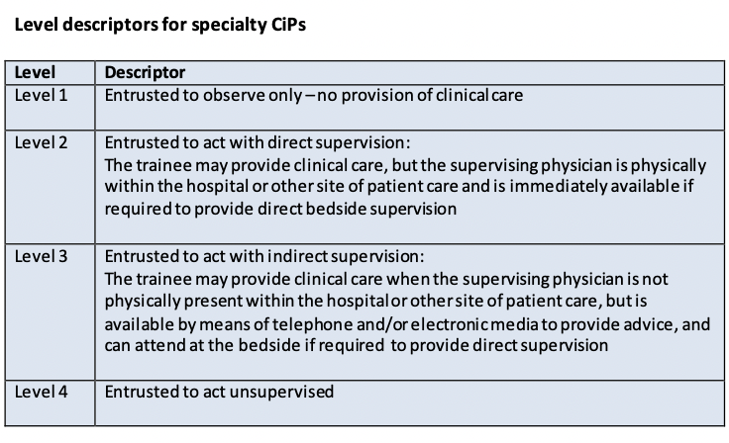

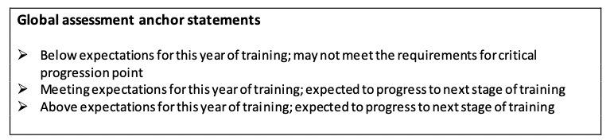

To be completed by trainee and countersigned by Educational Supervisor

Trainee signature: |  | Date:
Education Supervisor signature: |  | Date:
Education Supervisor name PLEASE PRINT

Pleural procedures should be undertaken in line with the British Thoracic Society guidelines. These state that thoracic ultrasound guidance is strongly recommended for all pleural procedures for pleural fluid, also that the marking of a site using thoracic ultrasound for subsequent remote aspiration or chest drain insertion is not recommended, except for large effusions. Ultrasound guidance should be provided by a pleural-trained ultrasound practitioner.
The requirement is for the trainee to be able to decompress a large symptomatic pneumothorax. This is a relatively uncommon clinical scenario, and it is not expected that all trainees will encounter it during their training. A trainee who can satisfactorily perform pleural aspiration of fluid can be regarded as having the necessary competency.
Level 3 should be achieved if possible
The entrustment decision for CiP2 may be made on the basis of performance in other related CiPs if the trainee is not in a post that provides acute specialty-related take experience

